Unit 2 Transformations

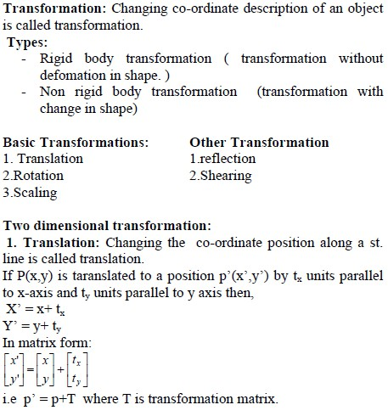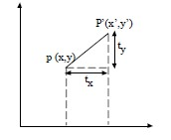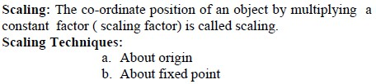

Geometrical transformations

Unit 2 Transformations

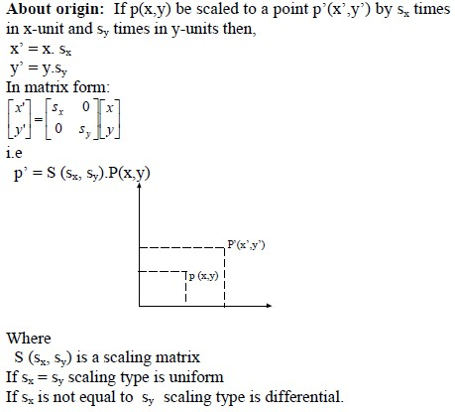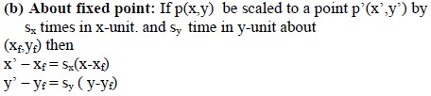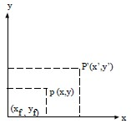

Unit 2 Transformations

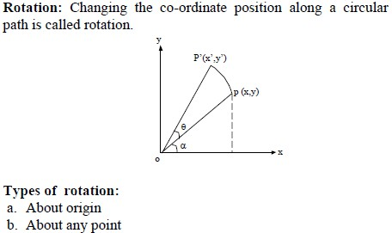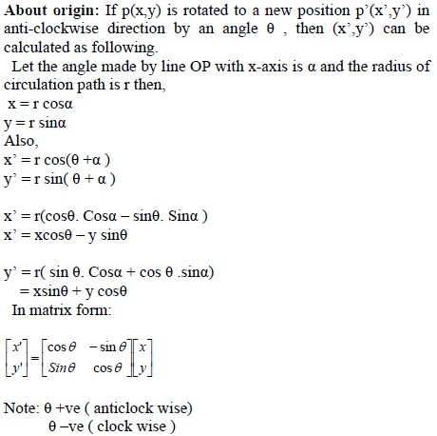

Unit 2 Transformations

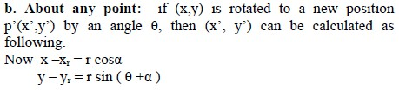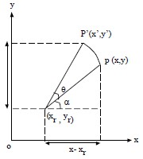

Matrix Representation and Homogeneous Co-ordinates

Many graphics applications involve sequences of geometric transformations. An animation, for   
example, might require an object to be translated and rotated at each increment of the motion. In   
order to combine sequence of transformations we have to eliminate the matrix addition. We can   
combine the multiplicative and translational terms for two-dimensronal geometric   
transformations into a single matrix representation by expanding the 2 by 2 matrix   
representations to 3 by 3 matrices. This allows us to express all transformation equations as   
matrix multiplications, providing that we also expand the matrix representations for coordinate   
positions. To express any two-dimensional transformation as a matrix multiplication, we   
represent each Cartesian coordinate position ( x,y) with the homogeneous coordinate triple (x,y,

h) .To achieve this we have represent matrix as 3 X 3 instead of 2 X 2 introducing an additional dummy coordinate h. Here points are specified by three numbers instead of two. This coordinate system is called as Homogeneous coordinate system and it allows expressing transformation equation as matrix multiplication

Cartesian coordinate position (x,y) is represented as homogeneous coordinate triple(x,y,h)

• Represent coordinates as (x,y,h)

• Actual coordinates drawn will be (x/h,y/h)

Unit 2 Transformations

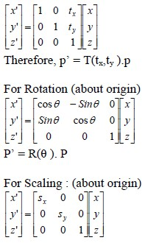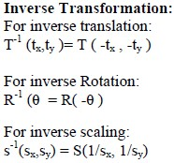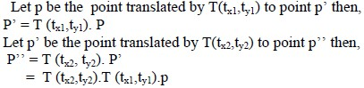

For Translation

Unit 2 Transformations

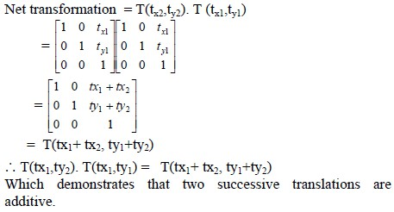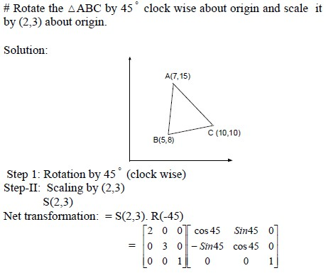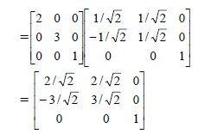

Unit 2 Transformations

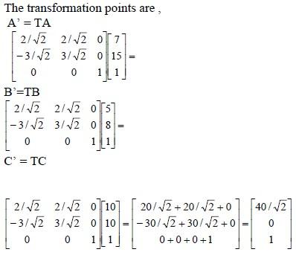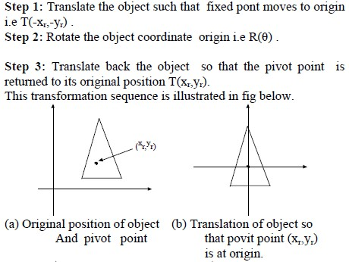

Unit 2 Transformations

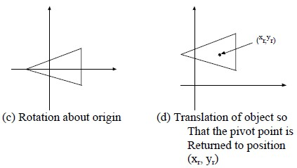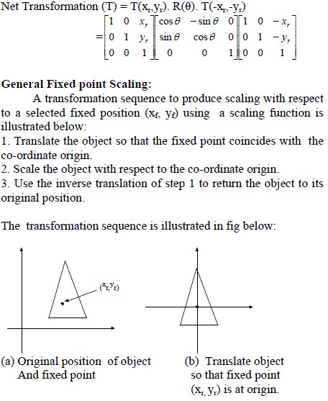

Unit 2 Transformations

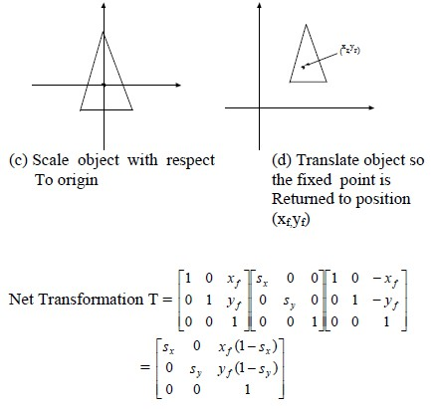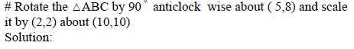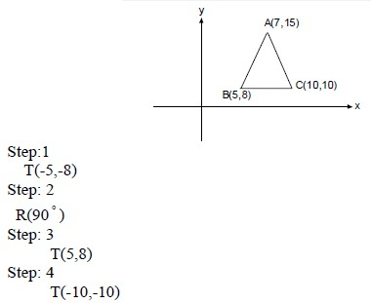

Unit 2 Transformations

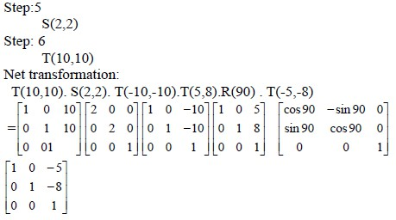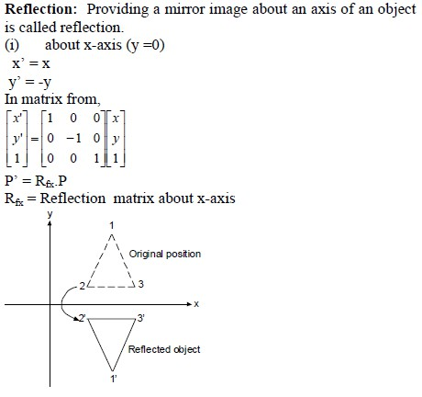

Other Transformations

1. Reflection

2. Shearing

Unit 2 Transformations

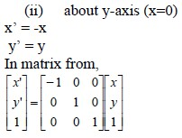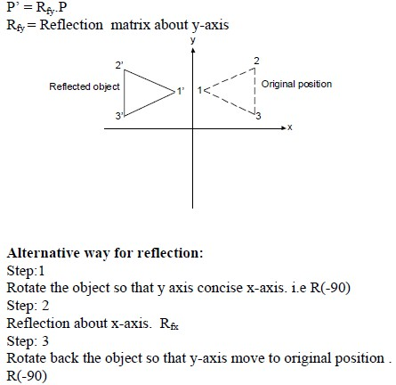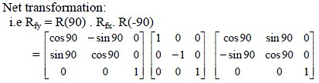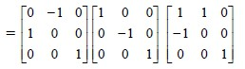

Unit 2 Transformations

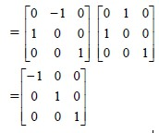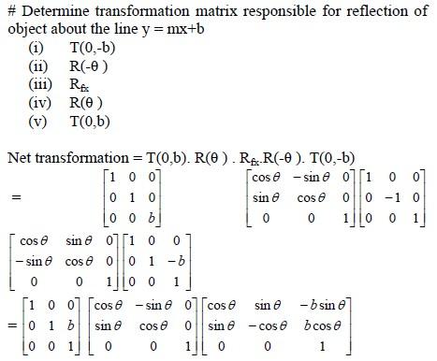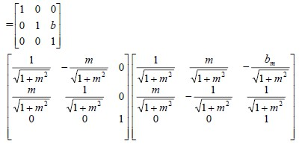

Unit 2 Transformations

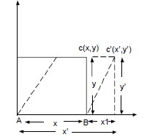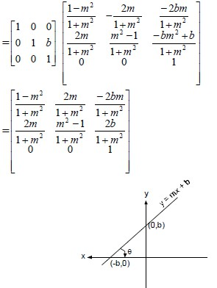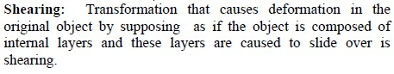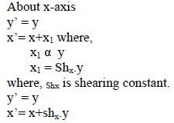

Unit 2 Transformations

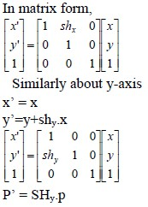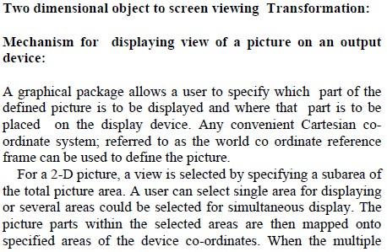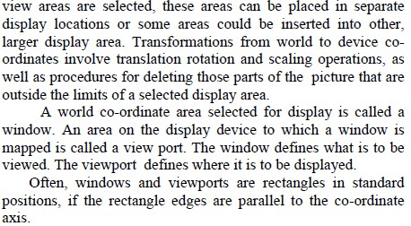

Unit 2 Transformations

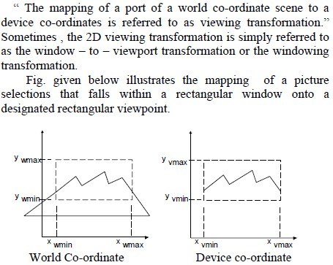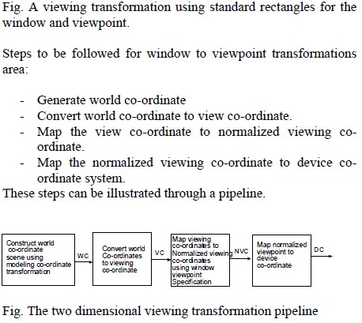

Unit 2 Transformations

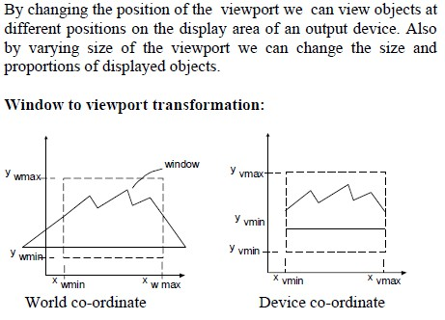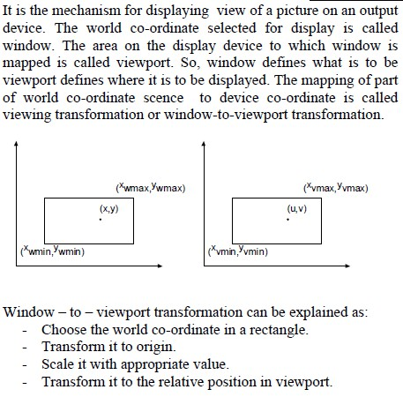

Unit 2 Transformations

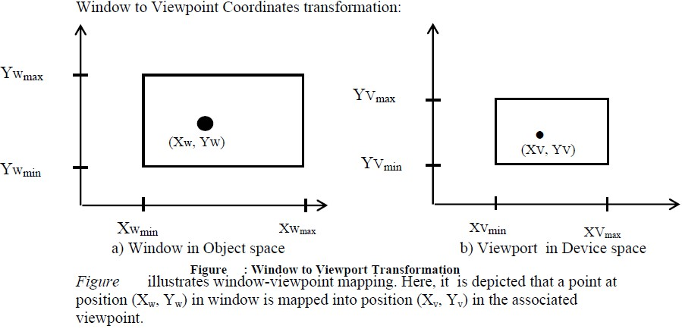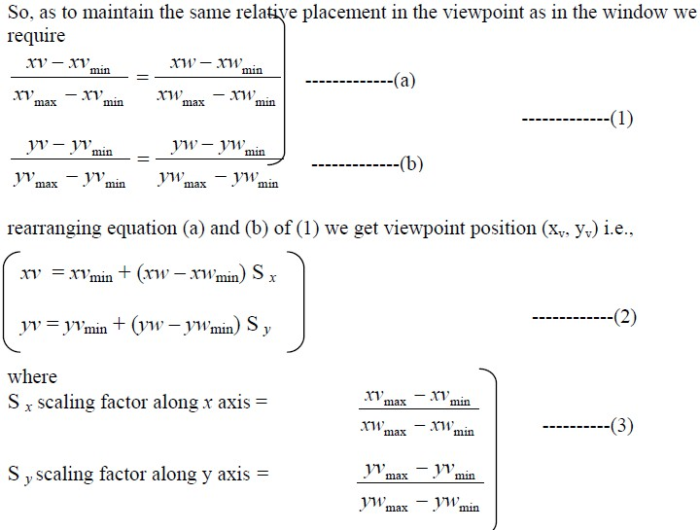

Note, if S = S then the relative proportions of objects are maintained else the world object will be

x y

stretched or contracted in either x or y direction when displayed on output device.

Unit 2 Transformations

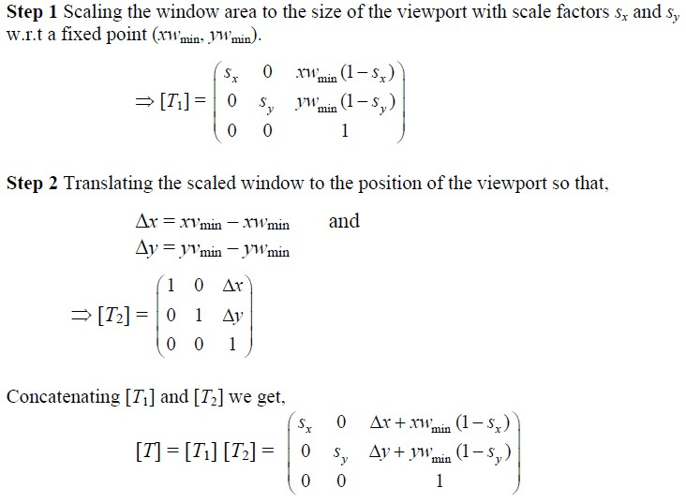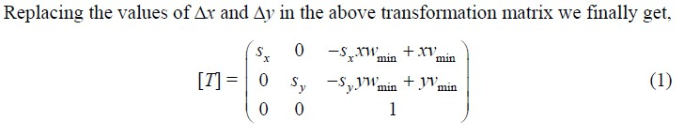

In terms of Geometric transformations the above relation can be interpreted through the following two   
steps:

Unit 2 Transformations

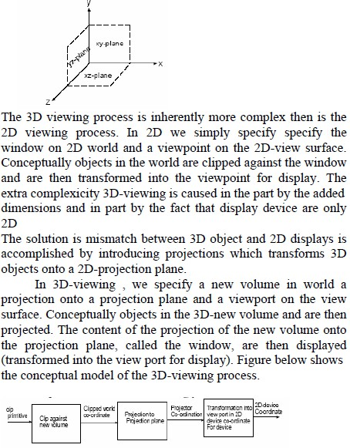

Three dimensional Graphics:

Three Dimensional object to screen perspective viewing Transfomation:

Unit 2 Transformations

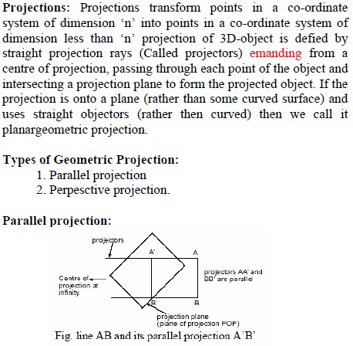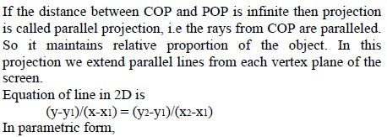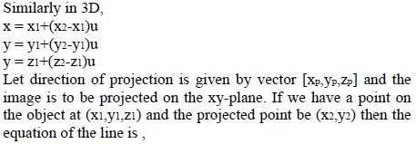

Unit 2 Transformations

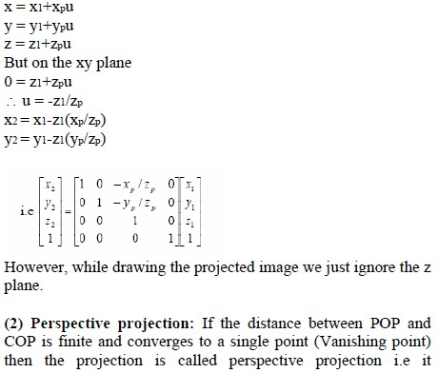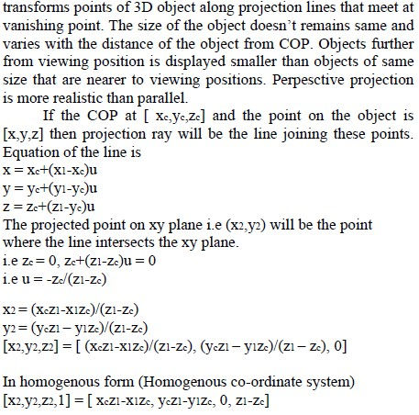

Unit 2 Transformations

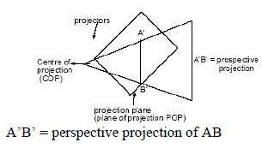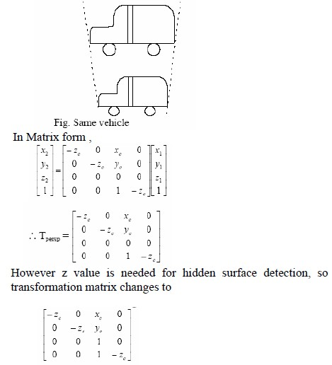

Extension of two-dimensional to three dimensional transformation:

Just as 2D-transfromtion can be represented by 3x3 matrices using homogeneous co-ordinate can be represented by 4x4 matrices, provided we use homogenous co-ordinate representation of   
points in 3D space as well.

Unit 2 Transformations

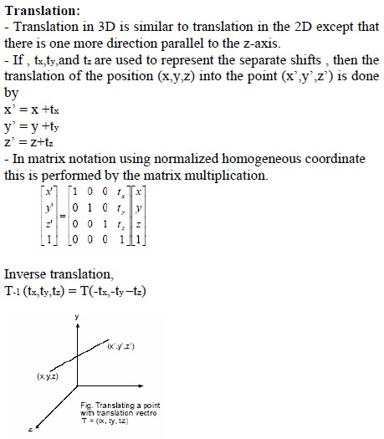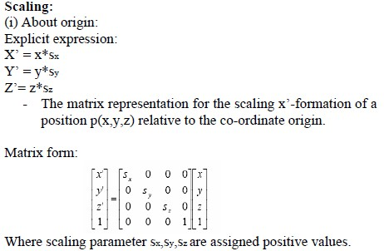

Unit 2 Transformations

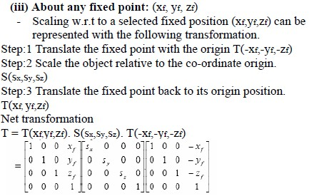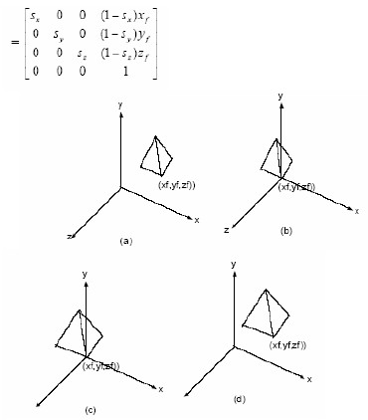

Unit 2 Transformations

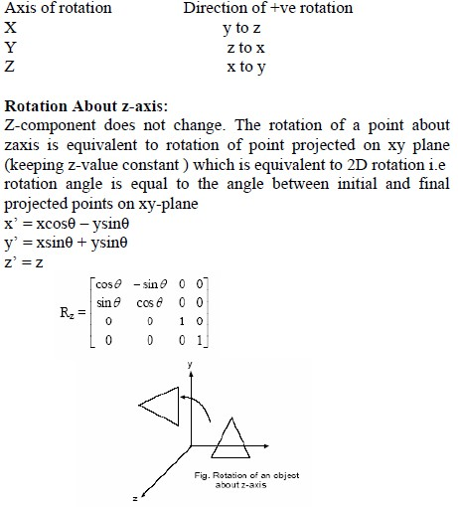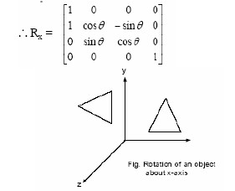

Rotation about x-axis:

x’ = x

y’ = ycosθ+zsinθ   
z’ = ysinθ+zsinθ

Unit 2 Transformations

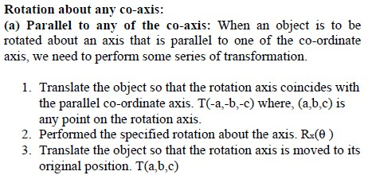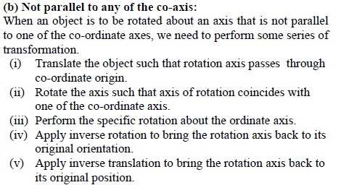

About y-axis:

Y’ = y

z = zcosθ - xsinθ   
x = zsinθ+ x cosθ

Unit 2 Transformations

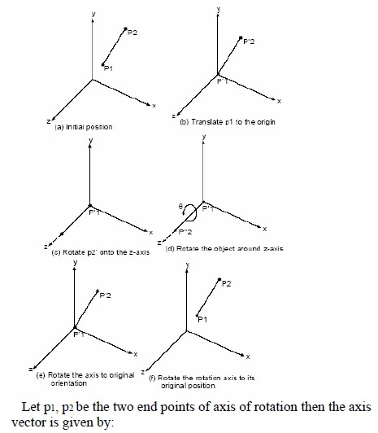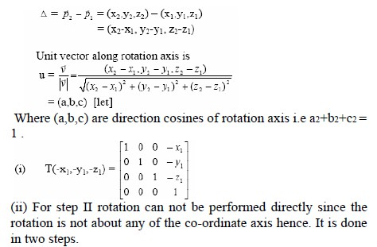

Unit 2 Transformations

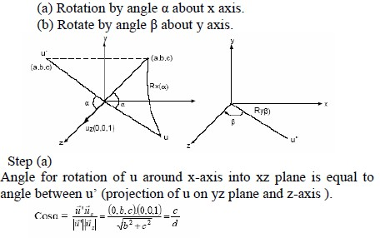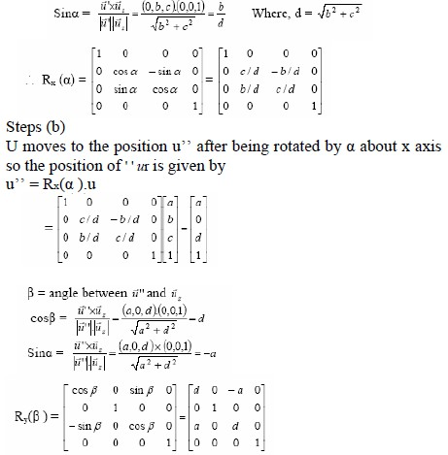

Unit 2 Transformations

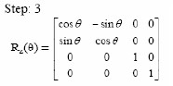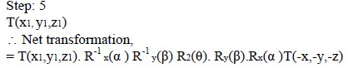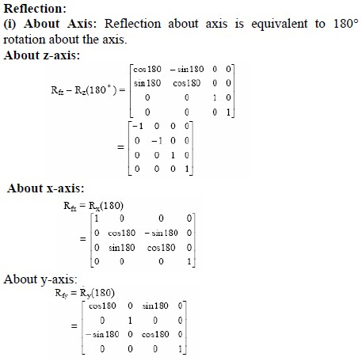

(ii) About any axis:   
Net transformation

Unit 2 Transformations

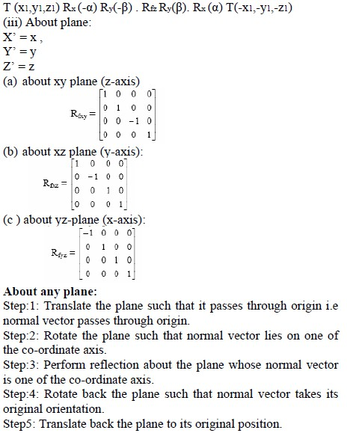

Shearing:

In 2D, shearing about x-axis means x-values changes by amount   
proportional to y-values and y-values remains same.   
However in 3D, z-axis means x and y value change by   
amount proportional to z-value and z-value remains same. i.e x’=   
x+ Shx.z

y’ = y + Shy.z   
z’ = z

Unit 2 Transformations

